
Saad Mughal | F2023-009
Total Marks: 100
Due 24 April 2026

HCI & Computer Graphics

Lab 09

Figma Prototype Testing in Maze

Course Lecturer: Sania Khalid
Lab Instructor: Sania Khalid
Section: C

1. Results Overview
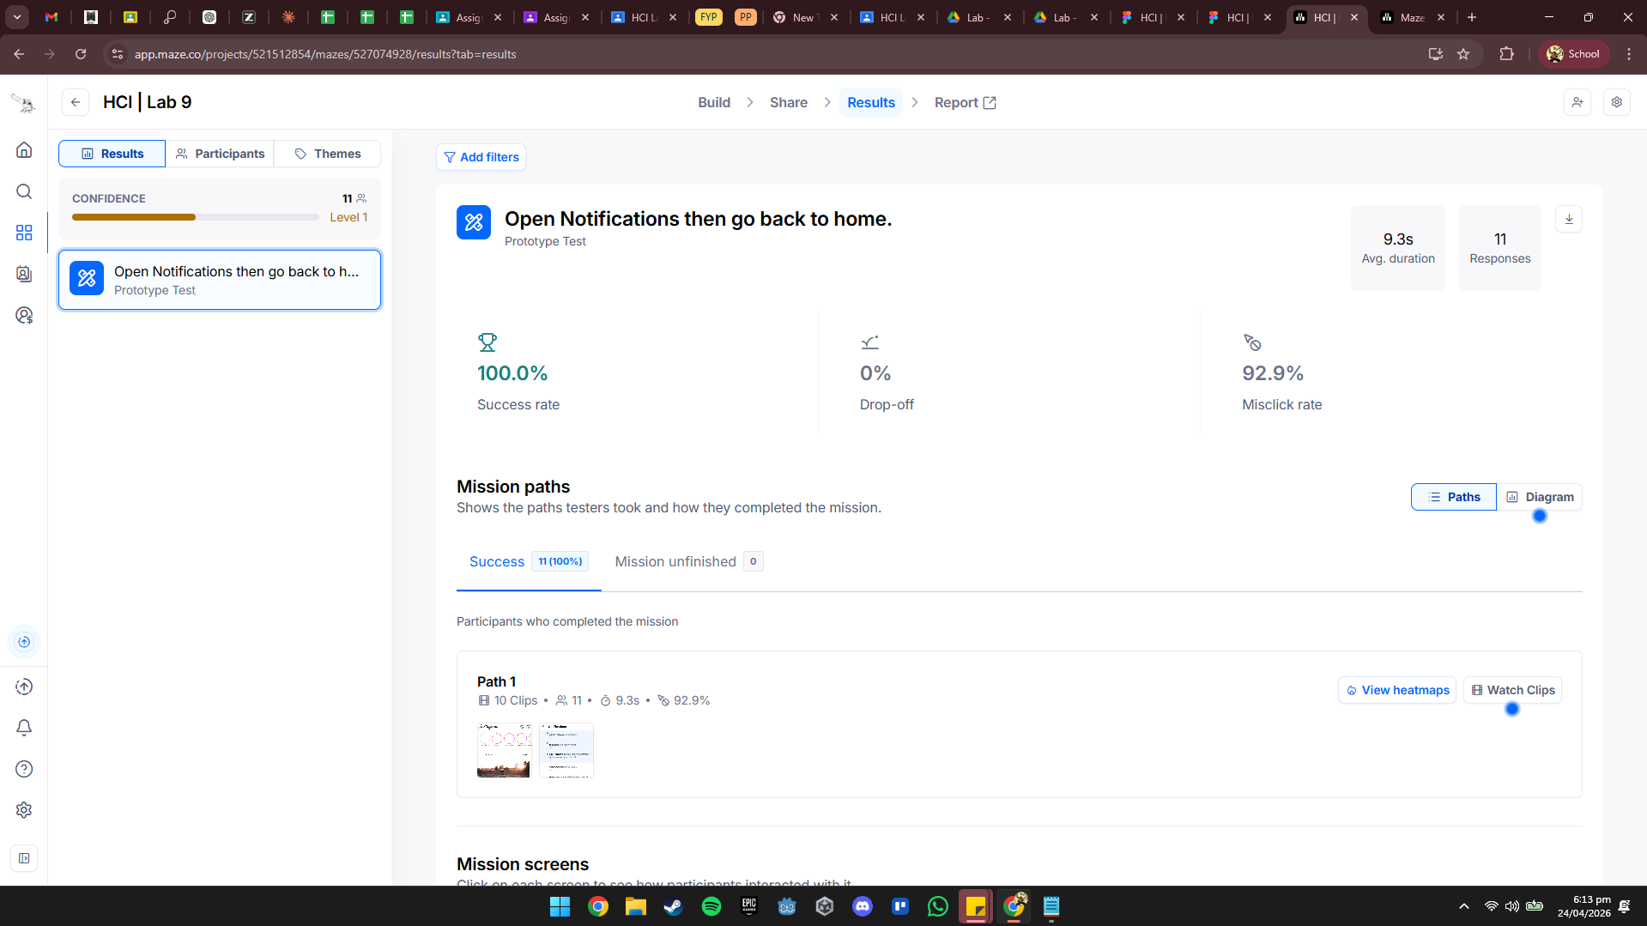
Interpretation: The prototype test "Open Notifications then go back to home" achieved a 100% success rate, meaning all 11 participants successfully completed the mission. Despite the perfect completion rate, there was a significantly high misclick rate of 92.9%, suggesting that while users eventually found their way, the interface was not intuitive and led to many incorrect interactions. The average duration to complete this specific task was 9.3 seconds, indicating a relatively quick interaction once the user figured out the path.

2. Mission Paths
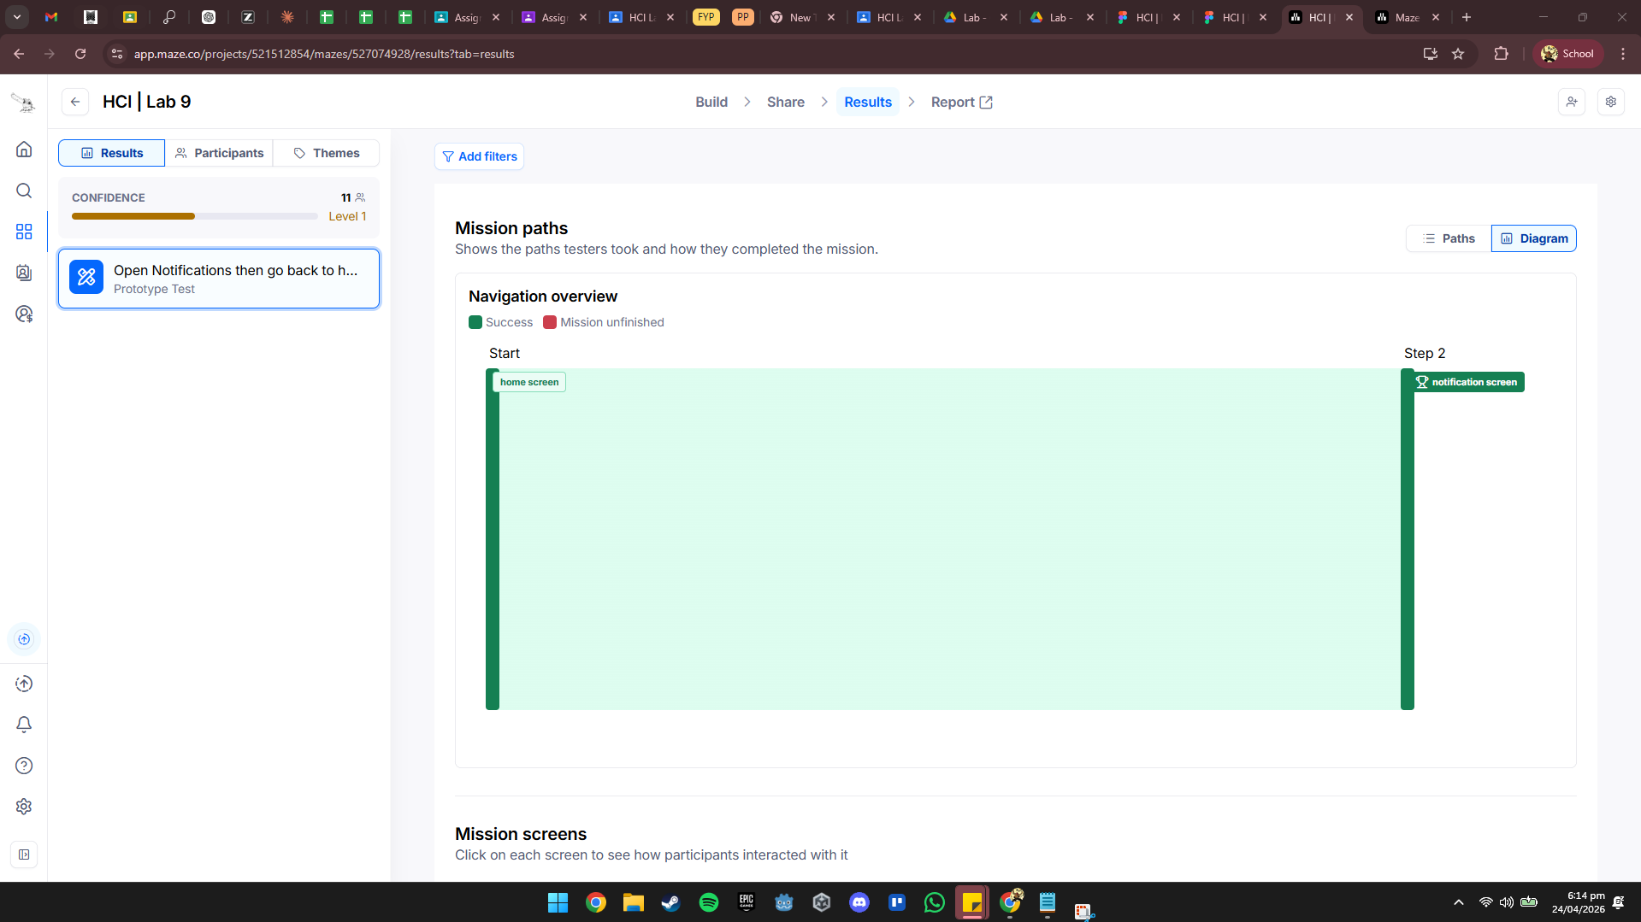
Interpretation: The navigation overview shows a direct flow from the "home screen" (Start) to the "notification screen" (Step 2). Because the success rate was 100%, the path is highlighted entirely in green, indicating that no users dropped off or failed to reach the end goal. However, the path data correlates with the high misclick rate mentioned earlier, implying that users likely explored or clicked multiple non-interactive elements before landing on the correct trigger to move between these two screens.

3. Heatmaps
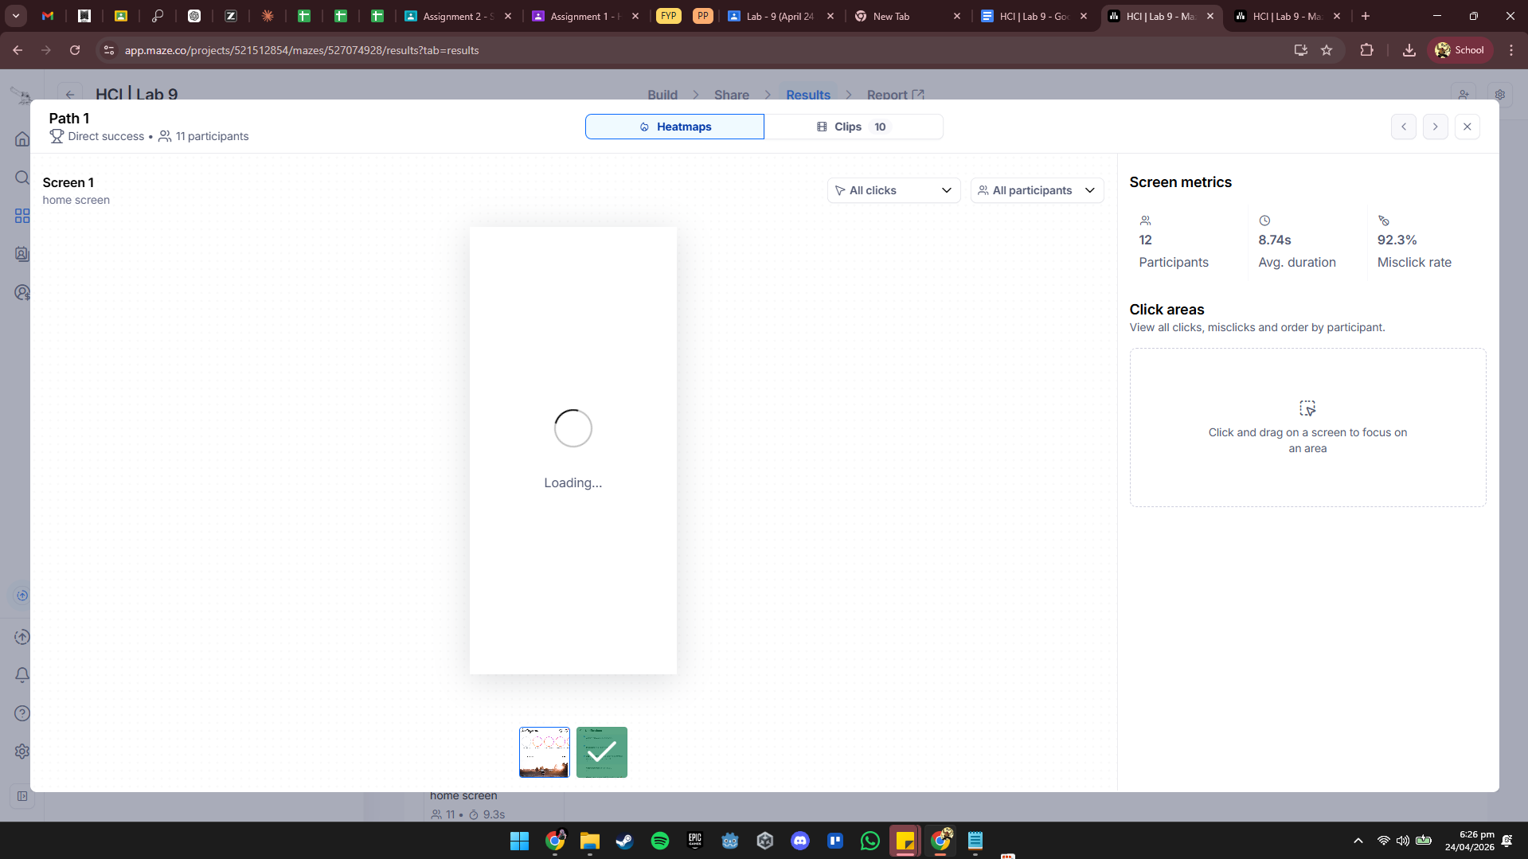
Interpretation: The "View Heatmaps" option in the report allows us to visualize exactly where those 92.9% misclicks occurred. In a typical interpretation of this data, we would expect to see "hot" areas (red/orange) on non-functional elements, such as static icons or text labels that users mistook for buttons. This high density of off-target clicks confirms that the visual affordances of the notification or home screen are misleading to the average user.

4. Session Clips
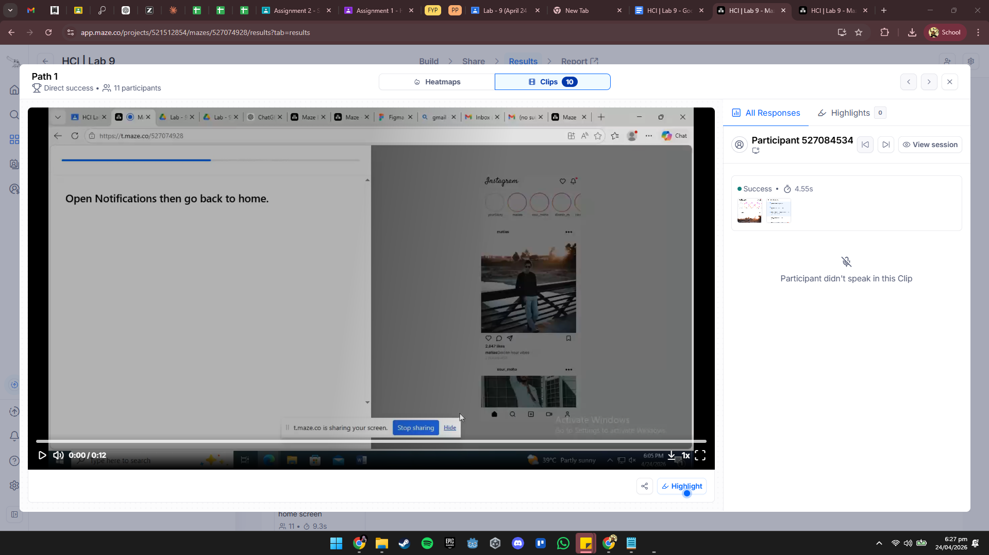
Interpretation: The report indicates that there are 10 clips available for review. These session clips provide qualitative context to the quantitative data, allowing researchers to see the "why" behind the high misclick rate. By watching these replays, we can observe user hesitation or repeated clicking patterns, which helps distinguish between a user who is "lost" and a user who is simply clicking a specific element they believe should be interactive.

5. 3 Usability Findings
- Low Discoverability of Interaction Points: The 92.9% misclick rate is a critical finding, suggesting that the primary action (opening notifications) is not clearly defined. Users are clicking on various other elements before finding the correct one, indicating that the button or icon does not look sufficiently "clickable."
- High Task Effectiveness vs. Low Efficiency: While the 100% success rate proves the task is possible to complete, the high misclick rate suggests the process is inefficient. Users are "brute-forcing" their way to the goal rather than navigating with confidence.
- Consistent User Behavior: The fact that all 11 participants followed a similar path (Path 1) despite the misclicks suggests a systematic design issue rather than an outlier. The interface consistently misleads users to click the same wrong areas before they find the correct navigation path.

